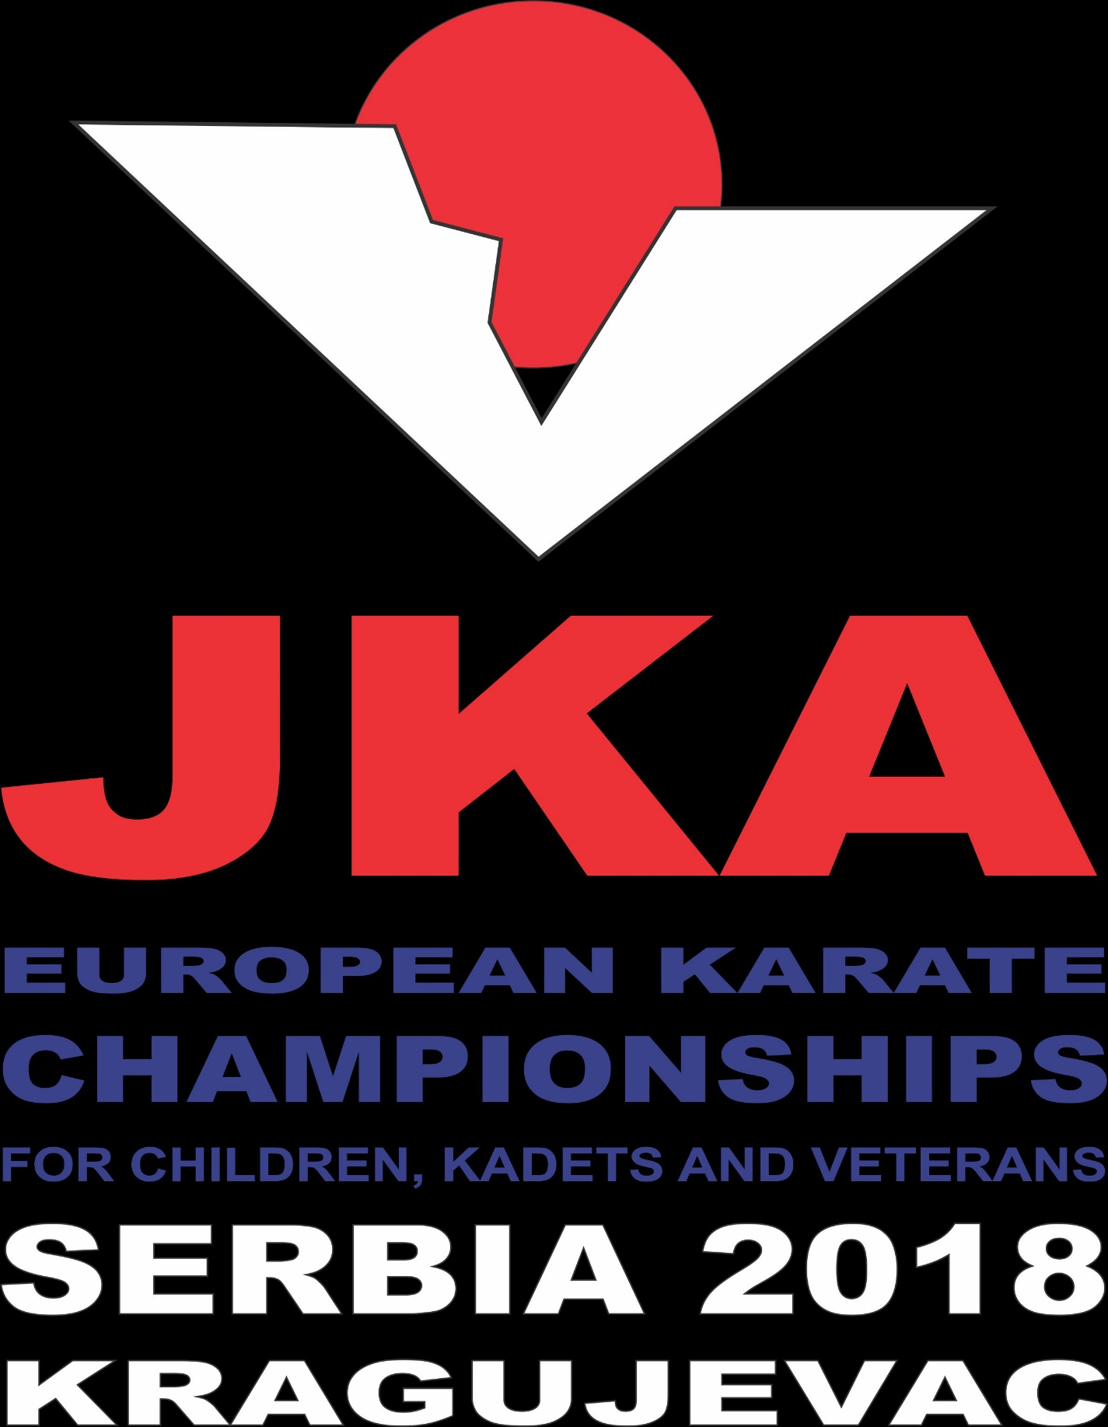

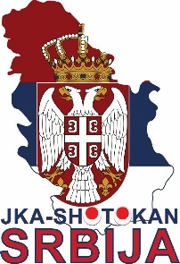
JKA - SHOTOKAN

FEDERATION OF SERBIA

JKA-WF / EUROPE

JKA-WF / Europe

13th JKA European Championships for children , cadets and veterans ( 9th),

26./27. May, 2018, Kragujevac - Serbia

by JKA-WF / Europe Technical Committee

JKA Serbia has the pleasure to invite you to the JKA European Championships 2018. These championships will take place in the sports center “ JEZERO” KRAGIJEVAC.

Please submit the requested information to us no later than April 2nd, 2018.
Feel free to contact us on our e-mail: jkashotokan@ptt.rs ; jkashotokanserbia@gmail.com should you
require more information.
We look forward to welcome you to KRAGUJEVAC and wish you a successful European Championships.
Best regards,
Oliver Tomic

GENERAL INFORMATIONS
www.jkaeuroyouth2018.com

ORGANIZATION

• Responsible organization: Karate JKA Shotokan Federation of Serbia

Oliver Tomic
Tel.: +381 60 055 0020 : +381 64 24054 59
Fax: +38137 655 311
E-Mail: jkashotokan@ptt.rs
jkashotokanserbia@gmail.com

• Date & Venue: 26. / 27. May 2018
SPORTS CENTER “ JEZERO “
KRAGUJEVAC
Address : Grada sirena 15
34000 Kragujevac , SERBIA

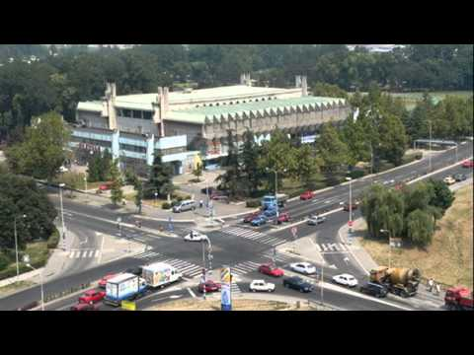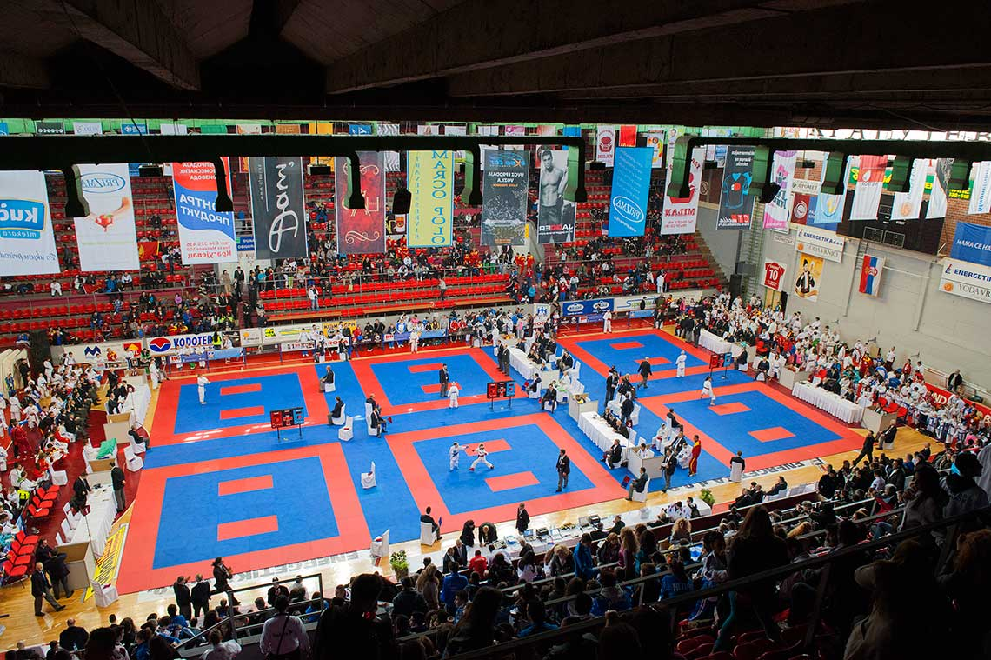

• Transport information:
There are airport from/to which we can organize transport:
• Belgrade „ Nikola Tesla“ Airport (140 km)

The price for the transport from/to the airport Belgrade ”Nikola Tesla” is 40,- Euro/person.

Please fill in Form A to book the transport from the airport to your hotel.
Deadline for the transport is April 2 ^{nd} , 2018

• Hotel information:

We reserve a room contingent in different hotels and hostels in Kragujevac .

HOTEL “ŠUMARICE “ / 180 beds ***** HEADQUARTER HOTEL *****
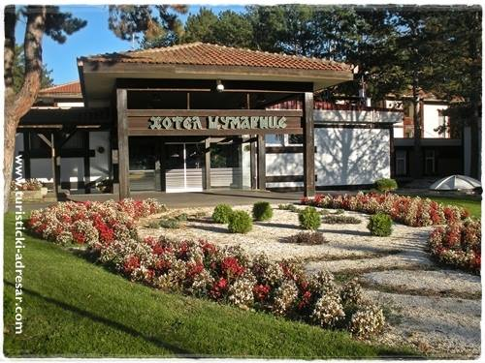
Address : Desankin venac , Kragujevac
Phone : +381(0)34/336-184 F: +381(0)34/300-177
e-mail : sumarice@sumaricedoo.com
http://www.hotelsumarice.com/
HOTEL “KRAGUJEVAC” / 170 beds
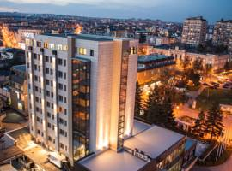
Address : Kralja Petra 1 br.18 , Kragujevac
Phone : +381 34 335-811
e-mail : recepcija@hotelkragujevac.com
www.hotelkragujevac.com
HOTEL “ZELENGORA” / 60 beds
Address : Branka Radičevića 22 , Kragujevac
Phone : +381 34 336 254
e-mail : zelengora@sumaricedoo.com
http://www.hotelzelengora.com

HOTEL „ŽENEVA LUX“ / 60 beds
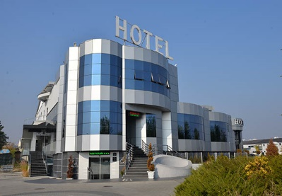
Address : Slobode bb , Kragujevac
Phone : +381 346356100
e-mail : office@zenevalux.com
http://www.zenevalux.com

HOTEL “ ŽENEVA” / 40 beds
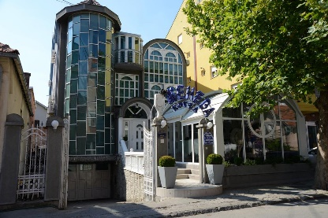
Address : Luja Pastera 19 , Kragujevac
Phone : +381 34 330-605

e-mail : hotelzeneva@gmail.com
www.hotelzeneva.com

HOTEL”ANDJELIKA” / 30 beds
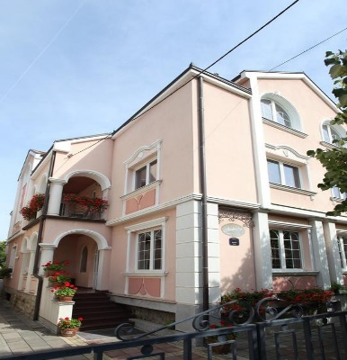
Address : Luja Pastera 13 , Kragujevac
Phone : + 381 34 365 461
e-mail : info@andjelika.rs

HOTEL”STARI GRAD” / 50 beds
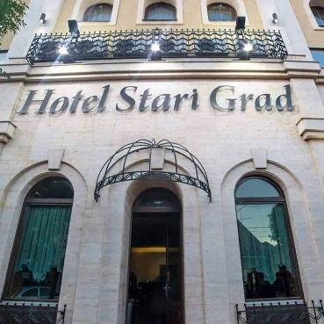
Address : Karađorševa 10 , Kragujevac
Phone : + 381 34/330-591
e-mail : oldtownkragujevac@gmail.com

GARNI HOTEL “EMA” / 36 beds
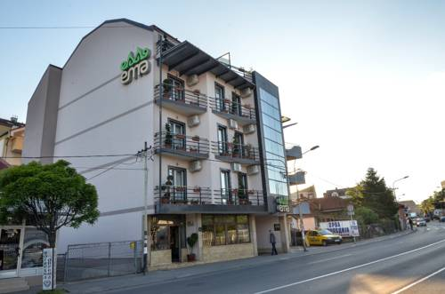
Address : Janka Veselinovića 91 , Kragujevac
Phone : +381 34 200-355, +381 60/45-05-836
e-mail : office@hotelema.rs

GARNI HOTEL “PRESIDENT de luxe” / 40 beds
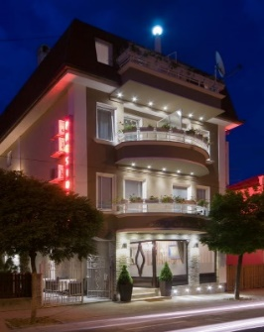
Address : Janka Veselinovića 52 , Kragujevac
Phone : + 381 34 6 305 935
e-mail : president@ptt.rs
http://www.hotelpresident.rs

GARNI HOTEL “LAZAREVIĆ / 50 beds
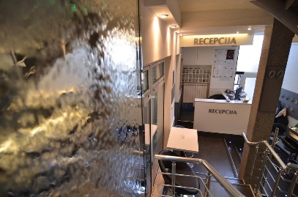
Address : Kralja Petra I 29/a , Kragujevac
Phone : +381 34 330256
e-mail : hotellazarevic@hotmail.com
www.hotel-lazarevic.rs

GUEST HOUSE „VILA JELENA“ / 50 beds

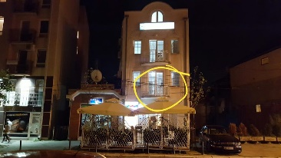
Address : Kralja Aleksandra 85 , Kragujevac
Phone : +381640644433
e-mail : vilajelenakg@gmail.com
https://www.facebook.com/vilajelenakg

GOLDEN LUX APARTMENTS / 12 beds
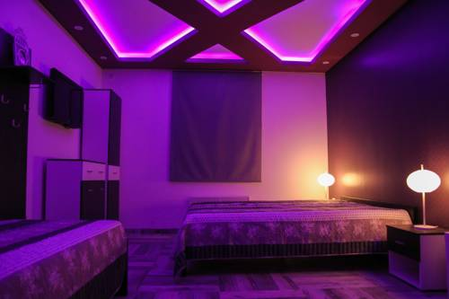

Address : Internacionalnih brigada 19, Kragujevac
Phone : +381 69 3444474
e-mail : hristikg@gmail.com

• Registration:
• Deadline for registration is April 2 ^{nd} , 2018 ; at the www.jkaeuroyouth2018.com
Register your competitors , referees , coachs and officials at the www.jkaeuroyouth2018.com

• We need the consent form of each participant (Form B)
• You have to show all passports of the participants at the registration.
(No copies – only original documents)
IMPORTANT :
For all competitors You must make passport photocopy (side with picture , name and birthday) and send by e-mail : jkashotokanserbia@gmail.com

• Competition fees:

Individual Kata: 15 Euro per person
Individual Kumite: 15 Euro per person
Team: 30 Euro per team

INFORMATION ABOUT PAYMENT
The fees for participation must be paid not later than 2nd April, 2018 otherwise your registration will not be considered. Please transfer the money to the below indicated account:

NOTICE : The complete amount given above pay to our account. Paying the costs of bank transfer is your obligation.

INSTRUCTION FOR COSTUMER TRANSFERS IN EUR
56: Intermediary
BCITITMM
INTESA SANPAOLO SPA
MILANO , ITALY

57: Account with institution:
SWIFT: DBDBRSBG
BANKA INTESA AD,BEOGRAD
MILENTIJA POPOVICA 7B
BEOGRAD,REPUBLIKA SRBIJA
59: Beneficiary:
IBAN: /RS35160005280000061019
JKA-SHOTOKAN SAVEZ SRBIJE
CUMICEVA 36
Krusevac
Republik of Serbia

TIME SCHEDULE

Thursday 24. May 2018
Arrival of delegations and accommodation
• 14h00 – 19h00: Registration at the HOTEL „ ŠUMARICE“

Friday, 25. May 2018: Arrival of delegations
• 14h00 – 19h00: Registration at the HOTEL „ ŠUMARICE“
• 17h00 – 18h00: Judge meeting. at the HOTEL „ ŠUMARICE“
All judge and referees
who participate in the judge meeting. All coaches from each
country SHALL be present at the judge meeting. All coaches
from each country SHALL also attend to the judge meeting.
If the coaches not attend the meeting they will not be allowed
to work as coach in the championship. All coaches shall obey
the rules and if they do not obey, the shushin have to turn out
them from the fighting area.
• 18h00 – 19h00: JKA Europe Meeting at the HOTEL „
„ ŠUMARICE“
• 19h00: President Meeting

Saturday, 26. May 2018: • 08h30: Opening (ex with 6 shiai jyo)
• 09h00: Start Kata and Kumite elimination each age category boys and girls
• 12h30: Lunch break half hour
• 16h30: Opening ceremony
• 17h30: Finals
• 19h00: End of first day competition

Sunday, 27. May 2018: • 08h30: Opening (with 6 shiai jyo,
• 09h00: Start Team Kata elimination each team categories
boys and girls After finals immediately medial awarding
Start Veterans Kata elimination men and women
• 12h30: Lunch break half hour
• 14h30: Start Team Kumite elimination each team categories
boys and girls After finals immediately medial awarding
• Finals Veterans kumite men and women
• After finals immediately medial awarding
• 19h00: End of second day

GENERAL RULES

Number of participants in individual age category

age 9– 17 years: 4 boys, 4 girls in Kata per country
4 boys, 4 girls in Kumite per country

• Kata must be JKA standardization
• Bow (Rei) in Kata shiai: bevor center into the direction of the shushin,
than bow to each other on the enbu-sen,
then musubi-dachi
After match rei each other on the enbu-sen
than out of shiai-jyo again rei.
• Bow (Rei) in Kumite shiai: Bow before enter shiai-jyo and on the enbu-sen bow each other
(respect each other). It is not necessary bow to the referee.
• Hansoku: Kumite – after 2 times win by hansoku-gachi than must
stop match, even no participate for kumite team.
• Only one official registered manager by country could make protest against th judge´s
decision.
• Each country can register I manager and up to 8 coaches.
• Every competitor must wear a white karate-gi with name or emblem of one´s own country
on the left chest, without any other publicity.
• Every competitor must wear an identification number (which will be assigned after the
registration and tournament´s organization) on his / her back.
• No change of contestants after the registration is admitted.
• Definition of age: The age of the contestants for each division is considered as that
of the first day of tournament (example 20th May 2013)
• Disqualification: Any contestant who is required to stop from the match by the
official appointed tournament doctor will be disqualified and
unable to continue. The doctor hold the decision.
• One country – one delegation. Only one organization will be allowed to represent a country.
• Each contestant must carry health insurance and is responsible for his / her own healthcare
beyond that which is available by the tournament doctors.

Individual Categories:

- 9 years old (Before the date of championship) up 7th Kyu

Kata boys and girls
Preliminary: flag system (to best 4) H1, H2, H3
Finals: point system (best 4) Tokui Kata: H2, H3, H4, H5

Kumite boys and girls:
Preliminary: Kihon Ippon (to best 4) Oizuki Jo, Chu, Mae geri
Finals: Kihon Ippon (best 4) Oizuki Jo, Chu, Mae geri, Mawashi geri
Defender – one counter attack on chudan
Only hand gloves required (no mouthpiece or chest protection
is needed)

- 10 years old (Before the date of championship) up 6th Kyu

Kata boys and girls
Preliminary: flag system (to best 4) H1, H2, H3, H4
Finals: point system (best 4) Tokui Kata: H2, H3, H4, H5, T1

Kumite boys and girls:
Preliminary: Kihon Ippon (to best 4) Oizuki Jo, Chu, Mae geri, Mawashi geri
Finals: Jiyu Ippon (best 4) Oizuki Jo, Chu, Mae geri, Mawashi geri
Defender – one counter attack on chudan

- 11 years old (Before the date of championship) up 5th Kyu

Kata boys and girls
Preliminary: flag system (to best 4) H1, H2, H3, H4, H5
Finals: point system (best 4) Tokui Kata: H2, H3, H4, H5, T1, BD

Kumite boys and girls:
Preliminary: Jiyu Ippon (to best 4) Oizuki Jo, Chu, Mae geri, Mawashi geri
Finals: Jiyu Ippon (best 4) Oizuki Jo, Chu, Mae geri, Mawashi geri
Defender – one counter attack on chudan

- 12 years old (Before the date of championship) up 5th Kyu

Kata boys and girls
Preliminary: flag system (to best 4) H1, H2, H3, H4, H5
Finals: point system (best 4) Tokui Kata: H2, H3, H4, H5, T1, BD, KD

Kumite boys and girls:
Preliminary: Jiyu Ippon (to best 4) Oizuki Jo, Chu, Mae geri, Mawashi geri
Finals: Jiyu Kumite (best 4) Shobu-Ippon, 2 minutes,
sai-sai shiai- Sakidori

- 13 years old (Before the date of championship) up 3rd Kyu

Kata boys and girls
Preliminary: flag system (to best 4) H1, H2, H3, H4, H5
Finals: point system (best 4) Tokui Kata: H2, H3, H4, H5, T1,
BD, KD, JO, Empi

Kumite boys and girls:
Preliminary: Jiyu Ippon (to best 4) Oizuki Jo, Chu, Mae geri, Mawashi geri
Finals: Jiyu Kumite (best 4) Shobu-Ippon, 2 minutes,
sai-sai shiai- Sakidori

- 14 years old (Before the date of championship) up 3rd Kyu

Kata boys and girls
Preliminary: flag system (to best 4) H2, H3, H4, H5, T1
Finals: point system (best 4) Tokui Kata: H2, H3, H4, H5, T1,
BD, KD, JO, Empi, Hangetsu

Kumite boys and girls:
Preliminary: Jiyu Kumite (to best 4) Shobu-Ippon, 2 minutes,
Sai-shiai 2 minutes, sai-sai shiai- Sakidori
Finals: Jiyu Kumite (best 4)

- 15 years old (Before the date of championship) up 3rd Kyu

Kata boys and girls
Preliminary: flag system (to best 4) H2, H3, H4, H5, T1
Finals: point system (best 4) Tokui Kata: BD, KD, JO, Empi, Hangetsu

Kumite boys and girls:
Preliminary: Jiyu Kumite (to best 4) Shobu-Ippon, 2 minutes,
Sai-shiai 2 minutes, sai-sai shiai- Sakidori
Finals: Jiyu Kumite (best 4)

- 16 years old (Before the date of championship) up 3rd Kyu

Kata boys and girls
Preliminary: flag system (to best 4) H2, H3, H4, H5, T1
Finals: point system (best 4) Tokui Kata: BD, KD, JO,
Empi, Hangetsu, Gankaku, Jitte

Kumite boys and girls:
Preliminary: Jiyu Kumite (to best 4) Shobu-Ippon, 2 minutes,
Sai-shiai 2 minutes, sai-sai shiai- Sakidori
Finals: Jiyu Kumite (best 4)

- 17 years old up 3rd Kyu
(18 years old – if they are born between 29th March 1997 and 24th May 1997)

Kata boys and girls
Preliminary: flag system (to best 4) H2, H3, H4, H5, T1
Finals: point system (best 4) Tokui Kata: BD, KD, JO,
Empi, Hangetsu, Gankaku, Jitte

Kumite boys and girls:
Preliminary: Jiyu Kumite (to best 4) Shobu-Ippon, 2 minutes,
Sai-shiai 2 minutes, sai-sai shiai- Sakidori
Finals: Jiyu Kumite (best 4)

Drawing rules for final Kata:
• In case of a draw, contestants must engage in an extra match (Sai-Shiai) with the same Kata.
• If at the end of an extra match there is still a draw, then the lowest score will be added.
• If there is again a draw, then the highest score will be added.
• If there is still a draw then the contestants must engage in additional an extra match
with a different Kata.

Team Categories:

- 10 - 11 years boys and girls (before the date of championship)

Team Kata
Preliminary: point system with 5 referees H1, H2, H3, H4, H5
Finals: (best 4) point system with 5 or 7 referees (not the same Kata) H2, H3, H4, H5

Team Kumite:
Preliminary: Kihon Ippon: Oizuki Jo, Chu, Mae geri
Finals: Kihon Ippon (best 4) Oizuki Jo, Chu, Mae geri, Mawashi geri
Defender – one counter attack on chudan

- 12 - 13 years boys and girls (before the date of championship)

Team Kata
Preliminary: point system with 5 referees H1, H2, H3, H4, H5, T1
Finals: (best 4) point system with 5 or 7 referees (not the same Kata) H2, H3, H4, H5, T1, BD, KD

Team Kumite:
Preliminary: Jiyu Ippon: Oizuki Jo, Chu, Mae geri
Finals: Kihon Ippon (best 4) Oizuki Jo, Chu, Mae geri, Mawashi geri
Defender – one counter attack on jodan or chudan

- 14 - 15 years boys and girls (before the date of championship)

Team Kata
Preliminary: point system with 5 referees H2, H3, H4, H5, T1, BD, KD
Finals: (best 4) point system with 5 or 7 referees (not the same Kata) H2, H3, H4, H5, T1, BD, KD, Jion, Empi

Team Kumite:
Preliminary: Jiyu Kumite
Finals: Jiyu Kumite (best 4)

- 16 - 17 years boys and girls
(18 years old – if they are born between 29th March 1997 and 24th May 1997)

Team Kata
Preliminary: point system with 5 referees H2, H3, H4, H5, T1, BD, KD
Finals: (best 4) point system with 5 or 7 referees (not the same Kata) H5, T1, BD, KD, Jion, Empi, Hangetsu, Jitte, Gankaku

Team Kumite:
Preliminary: Jiyu Kumite
Finals: Jiyu Kumite (best 4)

ATTENTION: Team Kumite: Hikiwake is allowed in team kumite.
Kihon Ippon Kumite: Feint is not allowed. One attack each by right side and right leg
In case of hikiwake: left side attack

VETERANS CATEGORIES

• 40+ years old - (bevor the date of championship)
• only individual men and women

Kata Men and Women:

Preliminary: flag system (to best 8) H2, H3, H4, H5, T1
Semi-finals: point system (best8 to best 4)
Sentei Kata: BD, KD, Jion, Empi, Hangetsu, Jitte, Gankaku
Finals: (best 4) Tokui Kata: (25 JKA Kata – different from semi-final)

Kumite Men and Women:

Preliminary: Jiyu Kumite (to best 4)
Protection: handgloves and mouthpiece
Shobu Ippon, 2 minutes, Sai-Shiai 2 minutes, sai-sai-shiai -
Sakidori-shobu
Finals: Jiyu Kumite (best 4)

Men´s veterans kumite in the finals, 5 minutes and no sakidori-shobu. Same as men´s kumite.

REFEREES:

• Bura Sensei will be the Technical Director for this Championships.
• Each country can send maximum 6 referees.
• Only referees with a JKA Europe or JKA World Federation license will be accepted.

Transfers will be made by buses, minibuses, and cars, based on the needs of participants teams.

- All participants staying in the hotels of the organization will have a special price on the transfers.
- The round trips from airports to the hotels of the organization will be guaranteed.
- 26./27. May buses will be available to transport all the hotels/hostels in the organization to the championship venue, at times to be defined.
- During the course of the event, transportation will be provided to and from the organizations hotels/hostels, with shedules to be defined and with requests to be made to organization.

PLEASE NOTE: THESE TRANSFERS WILL ONLY BE GUARANTEED FOR WHO STAY IN THE HOTELS / HOSTELS OF THE ORGANIZATION.

FORM A

TRANSFER FROM AIRPORT

Country:
E-mail address:

Arrival information
AIRPORT

Arrival date |  | Time
Airline |  | Flight number
Persons

Departure information
AIRPORT

Departure date |  | Time
Airline |  | Flight number
Persons

Transportation from Belgrade airport to the hotel and back: Transportation charges: 40 Euro per person

INFORMATION ABOUT PAYMENT NOTICE : The complete amount given above pay to our account. Paying the costs of bank transfer is your obligation.

The fees for transportation must be paid not later than 2nd April, 2018 otherwise your registration will not be considered. Please transfer the money to the below indicated account:

INSTRUCTION FOR COSTUMER TRANSFERS IN EUR
56: Intermediary
BCITITMM
INTESA SANPAOLO SPA
MILANO , ITALY
57: Account with institution:
SWIFT: DBDBRSBG
BANKA INTESA AD,BEOGRAD
MILENTIJA POPOVICA 7B
BEOGRAD,REPUBLIKA SRBIJA
59: Beneficiary:
IBAN: /RS35160005280000061019
JKA-SHOTOKAN SAVEZ SRBIJE
CUMICEVA 36
Krusevac , Republik of Serbia

FORM B

Consent Form
To: Organizing Committee of
JKA European Championship for children, cadets and veterans
26. / 27 . May 2018 / Kragujevac - Serbia

I hereby consent that I will not claim any compensation for injury, which might occur at the
JKA European Championships for children, cadets and veterans that will be held on 26. / 27. May 2018, at Kragujevac / Serbia.
Each contestant must carry personal health insurance and is responsible for his / her own health care and will have no claims to the tournament doctors

Name of Contestant: _______________________________________________________________
(type or print in capital letters clearly)

Signature: __________________________________ Date: ___________________

Address: _________________________________________________________________________

__________________________________________________________________________

Name of Parent / Guardian: __________________________________________________________
(type or print in capital letters clearly)

Signature: _____________________________________ Date: ___________________

Country:__________________________________________________

Note:
Type or print in capital letters clearly your name, and return this form to your manager. The manager must collect all this forms from the contestants of your country

